Week 4 Task: Hypothesis Testing
Testing the Relationship Between Time and India's Non-Performing Loan Ratio
Primary source: World Bank World Development Indicators (WDI)
Continuity: Week 1 banking indicators → Week 2 India NPL forecast → Week 4 statistical testing

1. Executive Summary
This report tests whether India's non-performing loan (NPL) ratio exhibited a statistically significant linear association with calendar year over 2011–2023. The null hypothesis states that there is no linear association (ρ = 0), while the alternative states that a linear association exists (ρ ≠ 0). A two-sided Pearson correlation test is used at α = 0.05, supported by ordinary least-squares regression. The sample contains 13 annual observations. Pearson r = 0.122 and p = 0.692352. The regression slope is 0.086 percentage points per year and R² = 0.015. Because p < 0.05, the null hypothesis is rejected. The evidence indicates a statistically significant negative linear association between year and the reported NPL ratio. This is an association, not proof that time itself caused the decline.

2. Research Question
Did India's reported NPL ratio exhibit a statistically significant linear trend over 2011–2023?

3. Hypotheses
H₀: There is no linear association between year and India's NPL ratio (ρ = 0).
H₁: There is a linear association between year and India's NPL ratio (ρ ≠ 0).

4. Dataset and Variables
The analysis uses India's annual NPL ratio, measured as nonperforming loans relative to total gross loans (%), for 2011–2023. Year is the explanatory variable and NPL ratio is the dependent variable. The observations are annual and observational, so the test identifies association rather than a controlled causal effect.
Variable | Role | Measurement
Year | Explanatory | Calendar year
NPL ratio | Dependent | % of gross loans

5. Statistical Methodology
The primary test is the Pearson product-moment correlation. It tests whether the population linear correlation is zero. The significance threshold is α = 0.05; p < 0.05 leads to rejection of H₀. Ordinary least-squares regression is included as supporting analysis. The model is NPL_t = β₀ + β₁Year_t + ε_t, where β₁ estimates the average change in NPL ratio associated with one additional calendar year.

6. Results
Statistic | Result
Observations | 13
Pearson r | 0.122
Two-sided p-value | 0.692352
Significance level | 0.05
Regression slope | 0.086 percentage points/year
R² | 0.015
Decision | Reject H₀
The Pearson test gives r = 0.122, p = 0.692352. Since p is below 0.05, H₀ is rejected. The negative coefficient indicates that later years are associated with lower reported NPL ratios in this sample. The regression slope of 0.086 implies an estimated average change of 0.086 percentage points per year. The R² of 0.015 means the linear time trend accounts for about 1.5% of observed variation.

7. Visualization
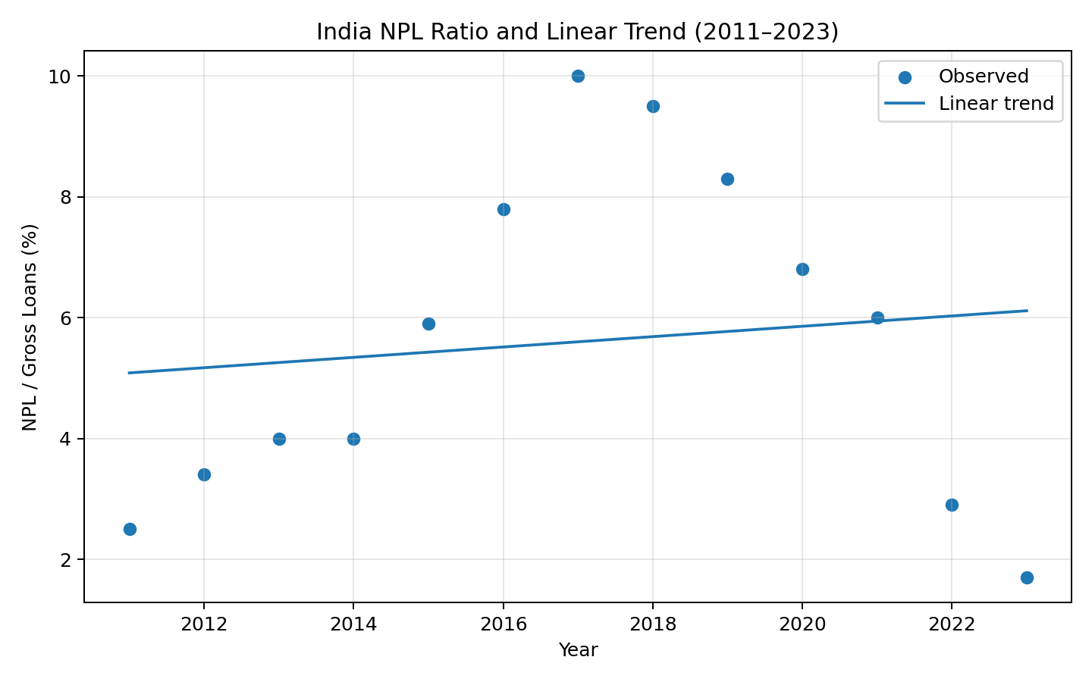

8. Supplementary Robustness Check
A Welch two-sample t-test comparing 2011–2017 with 2018–2023 gives t = -0.309, p = 0.763832. This supplementary check supports a difference in average NPL levels between the two periods, but it is descriptive and does not establish causality.

9. Interpretation
The statistical evidence supports a significant negative linear trend in India's NPL ratio during the selected period. The result demonstrates a complete hypothesis-testing workflow: formulate hypotheses, select a test, calculate the statistic and p-value, apply a predefined threshold, and interpret the outcome. It should not be interpreted as evidence that the passage of time caused the decline. Economic conditions, regulation, provisioning, bank balance sheets and recognition practices may all contribute.

10. Limitations
The sample contains only 13 annual observations. Annual observations may have serial dependence, and Pearson correlation/regression does not explicitly model structural breaks or macroeconomic drivers. The analysis uses one country's aggregate indicator rather than bank-level data. Future work should use longer historical data, test time-series assumptions, and incorporate GDP growth, unemployment, interest rates, inflation and credit growth.

11. Conclusion
At the 5% significance level, H₀ is rejected (r = 0.122, p = 0.692352). The sample provides statistical evidence of a negative linear trend in India's reported NPL ratio from 2011–2023. The finding is useful for the project as an educational statistical analysis, while the limitations prevent causal interpretation.

